1. Introduction

LessonDownloads

Lesson Introduction

Show TranscriptSummarize Video

Video Transcript

0:00

Welcome to a lesson on Agile teams.

0:03

In the last lesson,

0:04

we talked about the importance of Agile.

0:07

In this lesson, we will focus on agile teams,

0:11

which are the vehicle that delivers valuable work tied

0:14

to business-driven product features and functionality.

0:17

We will introduce the three core roles in Agile,

0:21

which is essential to understand how each role plays

0:24

a crucial part in successful Agile value delivery.

0:28

We will also discuss some of the characteristics of a high-performing Agile Team.

0:33

I will share my experiences around how to sustain high-performing teams by

0:37

avoiding some of the pitfalls that makes Agile teams lose steam and focus.

0:43

Once we have set the foundation for high-performing Agile teams and the three core roles,

0:48

we will look at an Agile team's optimal size,

0:51

structure, and cross-functional skills.

0:54

All of this is driven by the continual desire to elevate human capacity in

0:59

our Agile teams to deliver genuine value and satisfaction for all involved.

1:05

Our final important topic in this lesson will focus on Agile Governance and how

1:11

Agile Governance leverages the Agile Manifesto's guidelines

1:15

to balance assurance with adaptability.

1:18

By the end of this lesson,

1:20

you will be able to differentiate the three core roles of Product Owner,

1:24

facilitator, and team member.

1:26

By being able to differentiate between the three core roles,

1:30

you will be able to step into

1:32

an Agile environment knowing the norms of what these roles entail.

1:36

Identify the characteristics of a high-performing team.

1:41

When done right, Agile delivers on the promise of delivering high-performing teams.

1:47

Identify and implement the approaches for

1:50

high-performing team development and management.

1:53

This practical knowledge will help you be a valuable resource in Agile teams.

1:59

Implement methods for conflict resolution and psychological safety.

2:03

Your ability to manage conflicts with a positive mindset is a valuable skill to

2:09

develop Agile teams where interactions

2:12

among team members is more frequent than traditional project teams.

2:16

You will also be able to apply

2:19

Agile principles to create teams with optimal size and structure.

2:23

You will become a valuable asset to

2:25

organizations that are working to set up Agile team structures.

2:29

Develop effective cross-functional skills in a team.

2:33

We will discuss the value of T-shaped skills and what that means exactly.

2:39

Use best practices to manage and work with remote teams.

2:43

This has become even more important now with the realization of

2:47

the value of remote teams with the recent COVID-19 pandemic.

2:51

Apply governance to enable collaboration and decentralized decision-making.

2:57

Once you appreciate the value of decentralized decision-making,

3:02

you will be equipped to convince organizational leaders of its value.

3:06

Let's get right into it.

Welcome to a lesson on Agile Teams. In the last lesson, we talked about the importance of Agile.

This lesson will cover the following key topics:

High Performing Agile Teams

* How Agile Teams are the vehicle that delivers valuable work tied to business-driven product features and functionality.
* Characteristics of a high-performing Agile Team.
* How to sustain High Performing Teams.

Size, Structure, and Skills of an Agile Team

* The 3 core roles in Agile.
* An Agile Team’s optimal size, structure, and cross-functional skills.

Agile Governance

* Agile Governance and how Agile governance leverages The Agile Manifesto’s guidelines to balance assurance with adaptability.

By the End of the Lesson, You Will Be Able To...

* Differentiate the 3 core roles (Product Owner, Facilitator, and Team Member)
* Identify the characteristics of a high-performing team
* Identify and implement the approaches for high performing team development and management
* Implement methods for conflict resolution & psychological safety
* Apply Agile principles to create teams with optimal size and structure
* Develop effective cross-functional skills in a team
* Use best practices to manage and work with remote teams
* Apply governance to enable collaboration and decentralized decision making

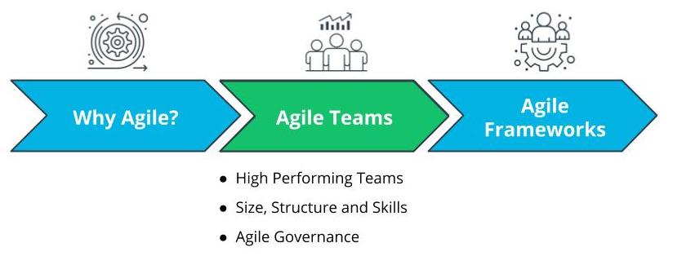

Lesson Overview - Agile Teams

# Why Agile Teams?

LessonDownloads

## Why Do Agile Teams Matter?

Show TranscriptSummarize Video

Video Transcript

0:00

Let's look at why Agile teams are such a critical vehicle to deliver valuable results.

0:05

An absolutely key driver behind anything Agile is the focus on value.

0:11

Each agile framework, which we will be discussing,

0:14

is driven by the goal of delivering

0:16

maximum business value that is aligned with the organization's vision.

0:23

A self-organizing team has the autonomy to make some decentralized decisions.

0:29

This allows for shared ownership of the work with the Agile team's buy-in.

0:33

This increases the motivation to both seek as well as accept greater responsibility.

0:39

Self-organization leads to team buy-in,

0:43

along with shared ownership,

0:45

and motivation, which leads to an increase in delivery of value by the Agile team.

0:50

A constructive conflict resolution atmosphere is essential.

0:55

Conflicts of all kinds are constructively

0:58

resolved because the team is driven by a shared vision.

1:01

This includes conflicts related to priorities,

1:05

technical decisions, and even interpersonal challenges.

1:09

The focus on Agile team goals keeps the team members focused

1:13

on the Agile team and not just their specific tasks.

1:17

This provides room for resolving conflicts in

1:20

a transparent yet respectful manner with a mature mindset.

1:25

Agile teams are an innovation hub that

1:29

spurs solutions for new or as yet unearthed requirements.

1:34

Agile teams with diverse and cross-functional skill sets

1:38

will envision a problem or challenge very differently.

1:42

This cultivates innovative solution options.

1:46

Agile teams cultivate mastery.

1:49

In Agile teams, time is put aside for learning and growth.

1:54

This allows Agile team members to sharpen their skills.

1:57

This built-in structure to hone their skills further motivates

2:01

the Agile team, and additional valuable results are produced.

2:06

This mindset of continual improvement is built-in alongside built-in quality.

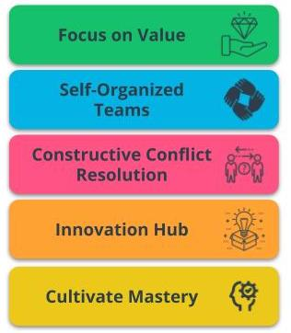

Benefits of Agile Teams

### Agile Teams are a critical vehicle to deliver valuable results because of the following:

* **Focus on Value** - Agile is driven by the goal of delivering maximum business value that is aligned with the organization’s vision.
* **Self-Organized Teams** - Agile Teams have the autonomy to make some de-centralized decisions, which allows for shared ownership of the work.
* **Constructive Conflict Resolution** - Conflicts in Agile Teams are constructively resolved because the team is driven by a shared vision.
* **Innovation Hub** - Agile Teams, with diverse and cross-functional skill sets, are an innovation hub that spurs solutions.
* **Cultivate Mastery** - Time is put aside in Agile Teams for learning and growth. This allows Agile Team members to sharpen their skills.

### Question 1 of 2

TRUE or FALSE: Small, independent teams are recommended in an Agile organization.



TRUE



FALSE

Submit

### Question 2 of 2

Why must organizations move away from command-and-control behaviors and structures? (There is more than one correct answer)



Command-and-Control structures are ill-suited to today’s rapid digital world



Agile enables executives to step back and oversee work with a light but consistent touch



Agile guarantees cheaper delivery of results



Teams excel when they are directed to the best opportunities and armed with the best people

Submit

### New Terms

* **Innovation Hub**: Proactively working towards continual improvement with no compromise on technical excellence and quality
* **Self-Organized**: The team determines tasks and makes technical decisions about the work to be done after being given priorities by the Product Owner

### Additional Resources

* [**5 Ways to Organize Agile Teams(opens in a new tab)**](https://www.scrumalliance.org/agile-resources/resources-for-your-agile-life/agile-advanced/may-2016/select-repost-5-ways-to-organize-agile-teams): This blog post from the Scrum Alliance describes five techniques to organize Agile teams successfully.

# How Experts Approach Agile Teams

LessonDownloads

## Thinking About Agile Teams

Show TranscriptSummarize Video

Video Transcript

0:00

Next, we're going to look at how experts approach agile teams.

0:04

Agilists believe that the secret sauce to success is teamwork.

0:08

Nothing is more critical to delivering exceptional products than spectacular teamwork.

0:14

Phenomenal agile teams live and breathe the "we" mindset rather than "I".

0:21

For agilists, nothing is more exciting and fulfilling than collectively innovating on

0:27

and building a product or solution that truly adds

0:30

value with motivated and engaged associates.

0:35

Now, there is no one single perfect formula for an exemplary agile team.

0:41

So while we respect the shared common agile values and principles,

0:45

business and contextual realities require us to adapt and be flexible.

0:49

Agilists take an agile approach to being agile.

0:54

Over the years, I have seen several Agile teams

0:57

flourish on the path to consistently deliver great results.

1:01

But this takes time and patient guidance from Agile transformations experts.

1:08

Agilists often remind organizations of the Tuckman model,

1:11

which has five stages of team development.

1:14

Agile teams experience the first four stages of this model

1:18

on their journey to progressing into an awesome agile squad.

1:23

During forming, the Agile team comes together and

1:28

the facilitator helps the team form into a cohesive group by explaining the ground rules,

1:34

product vision, and key outcomes expected.

1:38

The team then proceeds into the storming stage.

1:41

This is where a team's velocity or capacity to deliver value is diminished.

1:47

because there tends to be some confusion and ambiguity around the work to be done,

1:51

roles, and other product-related questions.

1:55

successful Agile teams quickly move away from storming to norming.

2:00

Once an Agile team gets to the norming stage,

2:04

the associates develop a sense of trust and camaraderie.

2:07

There's a healthy rapport built between the team members and

2:11

each team member starts to look for

2:13

the collective objectives of the team's long-term success.

2:17

Agile teams then progress to the level of

2:19

performing once they have successfully worked together over

2:23

a few iterations and have really gelled and

2:26

developed a strong cross-functional work style.

2:31

We keep a very practical and realistic approach to Agile product delivery and management.

2:37

On occasion, we get it wrong.

2:39

If it is ultimately determined by the business that a product is

2:43

not delivering value or is no longer needed in the market,

2:46

and cannot be pivoted relatively easily,

2:50

we consider adjourning the existing Agile team to

2:54

reallocate resources to other more valuable work in the organization.

2:58

Delivering value remains the guiding principle.

### Key Points About High Performing Teams

* Agilists believe that nothing is more critical to delivering exceptional products than teamwork.
* Agile Teams live and breathe the "we" mindset rather than “I."

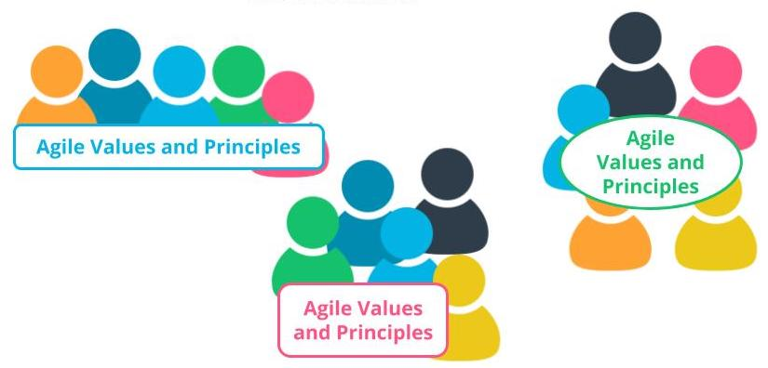

Teamwork is Agile's Secret Sauce

### Tuckman Model

The Tuckman Model, which has 5 stages of team development, describes how an Agile team progresses into an awesome Agile squad.

* **Forming** - Agile Team comes together and the Facilitator helps the team form by explaining the ground rules, product vision, and expected outcomes.
* **Storming** - This is where a team’s velocity is impacted because there tends to be some confusion and ambiguity around the work to be done, roles, and other product-related questions.
* **Norming** - Agile Team members develop a sense of trust and camaraderie. There’s a healthy rapport and each team member starts to look for the collective objectives of the team’s long-term success.
* **Performing** - Once an Agile Team has successfully worked together over a few iterations they should be in a state where they have gelled together and developed a strong cross-functional work style.
* **Adjourning** - If the business leaders realize that a product is not delivering value or is no longer needed in the market, the existing Agile Team members can be re-allocated to other more valuable work in the organization.

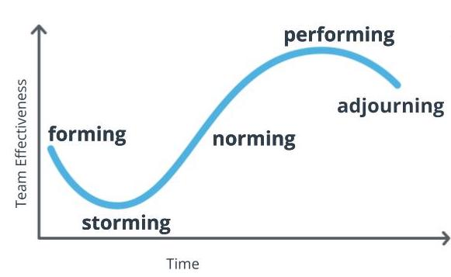

**The Tuckman Model**  
Adapted from: Tuckman, B. W. (1965). Developmental sequence in small groups. Psychological Bulletin, 63(6), 384–399.

### Question 1 of 2

A new Agile Team is being introduced to the project and the team is establishing ground rules. What Stage of Agile team development in The Tuckman Model is this team currently in?



Forming



Storming



Norming



Performing



Adjourning

Submit

### Question 2 of 2

Teams should immediately start delivering additional value as soon as they are introduced to Agile.



True



False

Submit

### New Terms

* **Adjourning**: The stage in the Tuckman Model where the Agile team’s goals have been completed, and the focus is on wrapping things up before team members get reassigned to other work
* **Forming**: The stage in the Tuckman Model when the team is getting accustomed to each other, ground rules are being established, and everyone is informed of the goals and objectives
* **Norming**: The stage in the Tuckman Model where a sense of trust develops among team members; interpersonal differences are taken care of now, and a sense of collaboration for the team's collective benefit arises
* **Performing**: The stage in the Tuckman Model where the team has matured into a well-established unit with a sharp focus on collaborative value delivery
* **Storming**: The stage in the Tuckman model where the team goes through a level of chaos in which there is confusion around the goals and objectives of the project, as well as confusion around roles and responsibilities

### Additional Resources

* [**High-Performance Teams - Why the Who Matters Less(opens in a new tab)**](https://www.scrumalliance.org/agile-resources/resources-for-your-agile-life/agile-advanced/march-2017/high-performance-teams-why-the-who-matters-less): Fabian Schwartz discusses how the collective team is more important than having superstars on board.
* B W Tuckman, ***Developmental Sequence in Small Groups***, Psychological Bulletin 63, 1965.  
  This is where Bruce Tuckman first introduced the Tuckman Model.

# Three Core Roles

LessonDownloads

## What Are the Three Core Roles?

Show TranscriptSummarize Video

Video Transcript

0:00

There are three core roles in the various agile frameworks.

0:04

The first is the product owner,

0:06

who is seen as the voice of the customer.

0:08

The next key role is that of the facilitator.

0:12

Then we have the agile team.

0:15

Let's look at all three of these important roles in detail.

0:18

A product owner, often referred to as PO in short,

0:23

is a critical role since the PO is responsible for working with

0:27

both the agile team as well as the business to

0:30

maximize the value of the product deliverables being worked on.

0:34

The product owner is primarily responsible for

0:37

prioritizing and managing the product backlog.

0:40

When the PO goes through the product backlog management and refinement,

0:44

it typically includes ensuring the product backlog items have

0:48

all the necessary details for the agile team to be able to estimate and work on it.

0:54

This includes the acceptance criteria,

0:56

prioritizing the product backlog items for maximum business value delivery,

1:02

and sharing the product backlog with key stakeholders and others to ensure everyone feels

1:08

the agile team's current and future planned work is visible and transparent to all.

1:14

Agile teams are self-directed and self-organized.

1:18

Management, along with the facilitator and PO,

1:22

empowers the agile team to organize and manage

1:25

their own work once the PO has prioritized the business needs.

1:29

This symbiotic relationship between the facilitator, PO,

1:34

and agile team optimizes

1:36

the agile team's overall confidence and ability to

1:39

deliver valuable product features in each iteration.

1:42

The agile team members are the ones who accomplish the actual work of completing

1:47

and delivering a potentially shippable version

1:49

of the product at the end of each iteration.

1:52

Strong agile team members exhibit T-shaped skills,

1:58

meaning they have tremendous depth in at least one thing but

2:02

are also capable of providing value in other areas outside their expertise.

2:06

This means that the team members are able to do role-blending by going beyond

2:11

their core vertical skill set to also help across the Agile Team with other needs.

### Three Core roles in Agile Frameworks: Product Owner, Facilitator, and Agile Team

* A **Product Owner**, often referred to as PO in short, is responsible for working with both The Agile Team as well as the business to maximize the value of the product deliverables being worked on. The Product Owner is primarily responsible for prioritizing and managing the Product Backlog, or the prioritized work item list.
* **Agile Teams** are self-directed and self-organized. The Agile Team members are the ones who accomplish the actual work of completing and delivering a potentially shippable version of the product at the end of each Iteration.

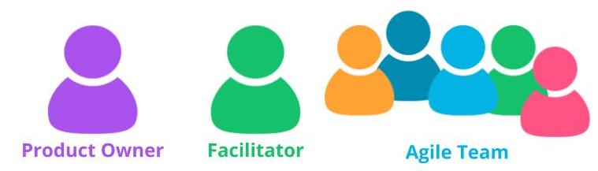

Three Core Roles in Agile

### Agile Team Members Exhibit T-Shaped Skills

When Agile Team members exhibit T-Shaped skills:

* They have tremendous expertise in at least one area.
* They are also capable of providing value in other areas outside their expertise.
* Team members are able to do role blending by going beyond their core vertical skill set.

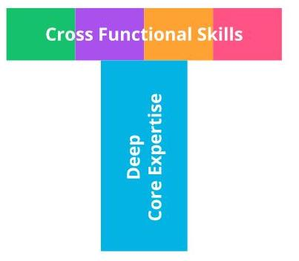

Agile Team Members Exhibit T-Shaped Skills

## Facilitator As Servant Leader

### To Serve and Support

Show TranscriptSummarize Video

Video Transcript

0:00

The facilitator is responsible for ensuring the Agile team moves

0:03

along at an acceptable pace towards the business objectives.

0:08

The facilitator plays an important role in helping the Agile team towards removing

0:13

any blockages or impediments that may be slowing the Agile team.

0:18

The facilitator is also usually an Agile coach who promotes Agile practices and values.

0:24

Facilitators are servant leaders who adopt

0:28

this leadership viewpoint in which the leader positions

0:31

himself or herself to serve and support.

0:34

This is in contrast to traditional leadership,

0:37

where the leader's purpose is to direct the team to meet the organizational goals.

0:42

When we talk about servant leadership,

0:44

we include active listening, respect, positive attitude,

0:49

neutralize personal biases, trust the Agile team's competencies,

0:55

raise relevant questions, as well as share power and control.

1:00

Since the facilitator is looking to maximize value created by the Agile team,

1:06

active listening is critical in this role.

1:08

The facilitator needs to fully concentrate and see things from the perspective

1:12

of others in the team who are seeking assistance or support.

1:16

As servant leader, the facilitator uses active listening to resolve any disputes

1:22

and reach decisions quickly so the team can move forward

1:25

without undue stress or interpersonal drama.

1:28

The facilitator will need to leverage non-verbal cues as well as paralingual messaging,

1:34

which is the tone of one's voice, to show

1:36

that they're paying attention and genuinely understanding.

1:39

Examples of non-verbal cues include nodding,

1:43

eye contact, and other body language to convey interest and empathy.

1:47

Respect is also important.

1:50

This aligns with the Agile mindset as discussed in the previous lesson.

1:54

Respect is critical for successful teamwork.

1:57

The facilitator, as a servant leader,

2:00

needs to model this desired Agile mindset by

2:04

exhibiting respect for associates at all levels of the organization,

2:07

the customer, as well as the prioritized product backlog.

2:12

The facilitator must treat everyone with integrity and honor.

2:16

A facilitator's positive attitude is enlightening for the Agile team.

2:21

Facilitators as servant leaders must model the desired behaviors of a positive attitude,

2:28

especially during times of crisis or confusion.

2:31

It is paramount that facilitators preserve a positive attitude.

2:36

A positive attitude is contagious in

2:39

a good way and spreads its positive energy very quickly.

2:42

The Agile team will quickly rally around

2:45

a facilitator who comes in with a breath of positive fresh air.

2:49

Unhealthy bias by someone in

2:51

this important facilitator role can have many negative consequences.

2:56

such as some members of the Agile team feeling unfairly excluded from experiences and

3:01

opportunities for which they think they are capable or qualified for.

3:06

It is important for a facilitator to recognize that this bias can be unconscious or

3:11

implicit and often has a subtle impact on a facilitator's attitude and behavior.

3:18

A facilitator must proactively take on

3:20

a servant leader attitude and confront this type of bias.

3:24

First, establish a working agreement.

3:28

Working agreements, also known as ground rules,

3:32

are mutually agreed upon rules of engagement that the Agile team

3:36

cultivates as to how they will work together to create a constructive,

3:41

collaborative, and productive environment.

3:44

Second, allowing and encouraging

3:47

role blending or the opportunity for team members to develop

3:51

cross-functional skills conveys a message that everyone on

3:55

the Agile team is welcome to develop their potential and avail of opportunities to grow.

4:01

Then, establishing transparent measurable goals is important.

4:06

This conveys a key message to everyone that

4:09

the measuring stick for performance is consistent and fair for all.

The Facilitator is responsible for ensuring the Agile Team moves along at an acceptable pace. The Facilitator is also usually an Agile Coach who promotes Agile practices and values.

### Facilitators are Servant Leaders Who Serve and Support

Servant Leadership adopts a leadership viewpoint in which the leader positions himself or herself to serve and support. Servant Leadership includes:

* Active listening
* Respect
* Positive attitude
* Neutralize personal biases

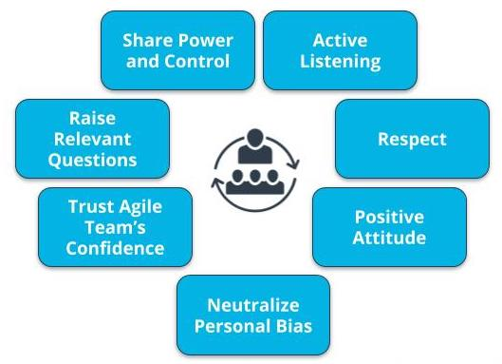

Characteristics of Servant Leadership

### Servant Leadership Helps the Team Deliver Results

Show TranscriptSummarize Video

Video Transcript

0:00

Trust is crucial between the facilitator,

0:03

PO, and Agile team.

0:06

As servant leader, the facilitator has to build

0:10

this trust for the Agile team to progress forward quickly.

0:13

The facilitator must also work to swiftly

0:16

improve and build trust between individuals on the Agile team.

0:20

Asking relevant questions with an honest and respectful tone is important

0:25

because it helps uncover both issues as

0:28

well as opportunities to find better options and solutions.

0:32

Facilitators need to have a curious mindset,

0:35

where they are in a learning mode rather than a judgment mode.

0:40

Facilitators stay curious and encourage the same behavior within their team members.

0:45

Asking unbiased, open-ended questions

0:48

will enable a facilitator to truly help the Agile team,

0:52

find solutions to challenges that may be slowing down progress.

0:57

Maintaining an open conversation flow also helps build

1:02

the Agile team's confidence in raising ideas in the open.

1:06

An honest and collaborative approach will nurture an environment where

1:10

Agile team members feel comfortable discussing issues openly.

1:14

This helps build strong Agile teams.

1:18

Servant leadership encourages sharing power with the Agile team

1:22

to encourage each team member's development and growth.

1:26

It also helps with better decisions.

1:28

Let's look at some of the key points related to power and control.

1:32

It is said that information is power.

1:35

As a servant leader,

1:37

the facilitator shares the power of information widely with everyone on the team.

1:42

This helps with better decisions,

1:44

and this transparency also leads to higher trust.

1:47

Knowledge is also power.

1:50

Again, servant leaders do not stockpile knowledge for themselves,

1:54

but rather they share it.

1:56

Facilitators are coaches, and by sharing knowledge,

1:59

they help team members become autonomous and self-organized.

2:03

An effective facilitator shares power by inviting others into the exercise of authority.

2:09

So how can a facilitator do that?

2:12

By actively and openly soliciting input and opinions in making team-level decisions.

2:19

Servant leadership helps a facilitator build a high-performing Agile team,

2:24

which in turn enables the facilitator to truly help

2:28

the Agile team attain monumental feats,

2:31

that positively deliver business value.

2:34

Once again, the three core roles are PO,

2:38

facilitator, and Agile team.

Servant Leadership also includes:

* Trust Agile Team’s competencies
* Raise relevant questions
* Shares power and control

Servant Leadership helps a Facilitator build a high-performing Agile team, which in turn enables the Facilitator to truly help the Agile Team achieve results that positively deliver business value.

### New Terms

* **Facilitator**: The person who ensures that the Agile Team moves along at an acceptable pace towards the business objective and removes any blockages or impediments that may be slowing the team
* **Self-Directed**: Team members are empowered to decide among themselves who does what and how it is to be accomplished in a collaborative manner
* **T-Shaped Skills**: A strong vertical skill combined with the capability and willingness to step into other cross-functional needs
* **Team Member**: The people who accomplish the actual work of completing and delivering a potentially shippable version of the product at the end of each iteration

### Additional Resources

* [**The Elusive Product Owner(opens in a new tab)**](https://www.scrumalliance.org/agile-resources/resources-for-your-agile-life/agile-advanced/march-2016/select-repost-the-elusive-product-owner): This Scum Alliance post discusses the critical role POs play in Agile teams.

# Exercise: Three Core Roles

LessonDownloads

## Assigning the Three Core Roles

As SocialKare.gov starts on its Agile transformation, the team will need to fill the core Agile roles.

Review the [**SocialKare.gov Case Study(opens in a new tab)**](https://video.udacity-data.com/topher/2020/September/5f5f6bc7_agnd-c1-foundations-of-agile-socialkare.gov-case-study/agnd-c1-foundations-of-agile-socialkare.gov-case-study.pdf) and

* Identify the three Agile Core roles and their responsibilities in the SocialKare.gov context
* Assign one of the listed SocialKare.gov employees to the Core Agile Roles
* Explain your assignments

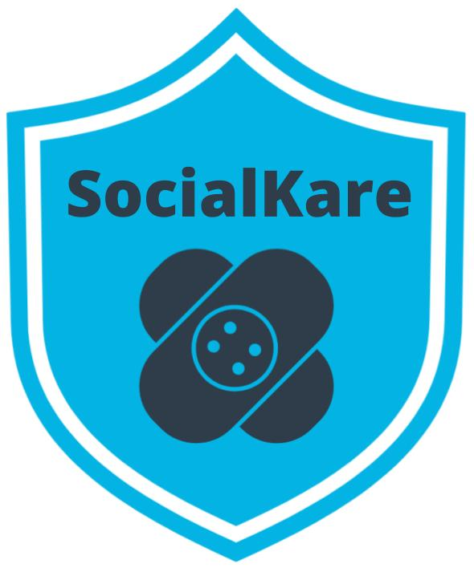

### Key SocialKare.gov Employees

This information also is available in the [**SocialKare.gov Case Study(opens in a new tab)**](https://video.udacity-data.com/topher/2020/September/5f5f6bc7_agnd-c1-foundations-of-agile-socialkare.gov-case-study/agnd-c1-foundations-of-agile-socialkare.gov-case-study.pdf).

* **John Details**: John is a detail-oriented individual who likes to plan everything out in tremendous detail. He has several years of experience as a Technical Project Manager. Prior to stepping into the role of Project Manager, John was a Developer. He is known to have good communication skills.
* **Sarah Tenure**: Sarah has been with the Agency responsible for launching SocialKare.gov for over 2 decades. Sarah has a lot of business knowledge and carries a certain amount of credibility due to this tenure. Sarah is strong-headed and likes to make decisions based on how she sees things because she believes she has better insight than others who may have been with the organization for as long as she has.
* **Tim Devs**: Tim has excellent technical skills. He prefers working as an individual contributor where he can spend time diving into the technical challenges on his own. He is well respected for his technical expertise. Tim maintains a strong focus on technical delivery and prefers the business users to stay out of his way while he is working through the development work. Tim leads a team of 5 developers with specialized vertical skills who are also on this project team
* **Jane Dollars**: Jane has sponsored this project. She is a senior executive and likes to stay involved with the day-to-day activities of projects that she sponsors.

# Solution: Three Core Roles

LessonDownloads

## My Solution

Show TranscriptSummarize Video

Video Transcript

0:00

In this exercise, you were asked to identify

0:03

the three Agile core roles and their responsibilities in the SocialKare.gov context.

0:09

From the three SocialKare.gov employees identified,

0:13

you were asked to identify three resources to

0:16

the core Agile roles and justify

0:19

your answers based on the core roles and responsibilities.

0:23

Well, let's look at my responses.

0:26

The exercise was to identify the three core roles and

0:30

their responsibilities in the Healthcare.gov context again.

0:33

Let's start with the facilitator role.

0:36

This role which can double up as an Agile team coach or project lead at SocialKare.gov.

0:43

is responsible for facilitating the Agile team's work,

0:46

obtaining resources for it,

0:48

and protecting it from problems.

0:50

This role will encompass the soft skills of project management,

0:55

but not necessarily the technical ones,

0:57

such as planning and scheduling.

0:59

Activities which are better left to the SocialKare.gov Agile team as a whole.

1:05

The recommended employee is John Details.

1:09

John has good communication skills, which are critical for a facilitator in an Agile team.

1:15

His experiences as a project manager can also be helpful for SocialKare.gov.

1:20

The next core role is the product owner.

1:23

The product owner represents the SocialKare.gov stakeholders,

1:27

and specifically is known as the voice of the customer.

1:30

This is the one individual who's responsible for the prioritized work item list,

1:35

called a product backlog.

1:37

This role in SocialKare.gov will be responsible for prioritizing the backlog,

1:42

share business decisions in a timely manner,

1:45

and for providing any requirements or

1:47

functionality-related information to the Agile team in a timely manner.

1:53

The recommended employee is Sarah Tenure.

1:56

Sarah brings business acumen and credibility in front of the business users.

2:01

Her experience and relationships with business leaders will help in

2:05

eliciting requirements as well as in negotiating priorities.

2:09

The next core role is Agile team member.

2:13

This role at SocialKare.gov will primarily include

2:17

developers who are responsible for the creation and delivery of a system.

2:21

However, all other Agile team members will also be included in this category.

2:26

This includes, but is not limited to, those who will conduct modeling, programming,

2:33

testing, business analysis, front-end design,

2:37

release activities, and others.

2:40

The recommended employee is Tim Devs.

2:43

Tim brings important technical skills that are required to

2:47

deliver the SocialKare.gov features and functionality.

2:50

Was your solution different from mine?

2:53

Think about the responsibilities of each core role and

2:56

the strengths of the SocialKare.gov team members.

### Identify the Three Agile Core Roles and Responsibilities for the SocialKare.gov Team

* **Facilitator** - Can double up as an Agile Team coach or project lead at SocialKare.gov, is responsible for facilitating the Agile Team’s work, obtaining resources for it, and protecting it from problems. The recommended employee is ***John Details***.
* **Product Owner** - Represents the SocialKare.gov stakeholders and specifically is known as The Voice of the Customer (VOC); the one individual who is responsible for the prioritized work item list, called a Product Backlog; will be responsible for prioritizing the backlog, share business decisions in a timely manner, and for providing any requirements or functionality related information to the Agile Team in a timely manner. The recommended employee is ***Sarah Tenure***.
* **Agile Team Member** - Primarily includes developers who are responsible for the creation and delivery of a system; However, all other Agile team members will also be included in this category. This includes, but is not limited to, those who will conduct modeling, programming, testing, business analysis, front-end design, release activities, and others. The recommended employee is ***Tim Devs***.

1. High Performing Agile Teams

LessonDownloads

What Is a High Performing Agile Team?

Show TranscriptSummarize Video

Video Transcript

0:00

A high-performing agile team never disappoints.

0:03

Such agile teams deliver phenomenal results consistently,

0:07

regardless of the challenges they encounter.

0:10

Such agile teams model desired

0:13

behaviors and characteristics across the organization they reside in,

0:18

since they surpass both their leaders' and customers' expectations without fail.

0:24

Let's delve into such high-performing teams.

0:28

When organizations do it right,

0:30

agile teams thrive to become high-performing teams.

0:34

Agile teams have the following in common:

0:37

they are independent and self-directed,

0:41

small T-shaped teams, focused on mission,

0:47

and supported by executives.

0:50

Senior leaders in an organization can turbocharge

0:53

an agile team by enabling them to be self-directed and independent.

0:57

This propels the agile team forward by unleashing

1:01

their ambition and cutting

1:03

the unnecessary red tape that slows the flow of value delivery.

1:08

High-performing agile teams are

1:11

those inspired and motivated units through

1:13

which agile, product-centric value gets delivered.

1:17

A successful agile organization deploys several such small agile teams,

1:23

each of which is composed of skilled individuals who have T-shaped skills and are

1:28

able to support each other in the agile team through role blending.

1:33

High-performing agile teams are focused on

1:36

the mission they have been assigned to carry out.

1:38

This fusion of multidisciplinary skills within

1:42

an agile team has tremendous benefits for the organization.

1:46

Rather than having the work broken out into silos by functional expertise,

1:51

high-performing agile teams are lodged with the skills

1:56

required to independently work on continually delivering high-value results.

2:02

Leaders do play a critical role here.

2:05

They have to create the right environment to allow agile teams to thrive.

2:09

This requires the leaders to encourage and sometimes even

2:12

push the culture to transform away from

2:15

a command-and-control structure that inhibits

2:18

an organization's ability to effectively compete in today's rapid digital world.

2:23

A big challenge for leaders is to break down the silos since

2:28

independent agile teams cannot possibly conquer such blockages on their own.

2:33

Once an agile team is equipped with

2:35

the right skilled resources and the appropriate supporting tools and environments,

2:40

leaders can step back and let high-performing teams flourish.

2:45

Again, the key is to allow the agile team to make work-related decisions on their own.

2:51

In order for this to happen, each agile team needs to

2:54

work in a structure that has minimal dependence on other functions,

2:57

which might include units like finance or human resources, for example.

3:02

Highly motivated and skilled resources is

3:05

a key ingredient to building a strong performing agile team.

3:09

High-performing teams have a shared sense of purpose,

3:12

So the agile team works to make sure that everyone on the team has a clear view of

3:18

what is important to the customers in terms of priorities and value.

3:24

Ground rules or team norms are a list of mutually

3:28

agreed-upon behaviors and rules that an agile team decides upon.

3:33

so these are not dictated from management nor the facilitator or product owner.

3:39

Ground rules are useful for working together as

3:42

an agile team in both a productive as well as respectful manner.

3:45

A list of written ground rules is especially useful for

3:50

guiding group behavior towards a common purpose.

3:55

Ground rules are part of nurturing an environment where the agile team members can

4:00

bring up different topics and enter into constructive yet challenging conversations.

4:05

Agilists refer to ground rules as

4:08

the enabler for agile teams to discuss the undiscussables.

4:13

Ground rules or team norms are also known as working agreements.

High Performing Agile Teams have the following in common.

They are:

* Independent and self-directed
* Small, T-shaped teams
* Focused on the mission
* Supported by executives

Moreover, Agile Teams make decisions on their own. They also develop team norms and ground rules, which are useful for guiding group behavior towards a common purpose.

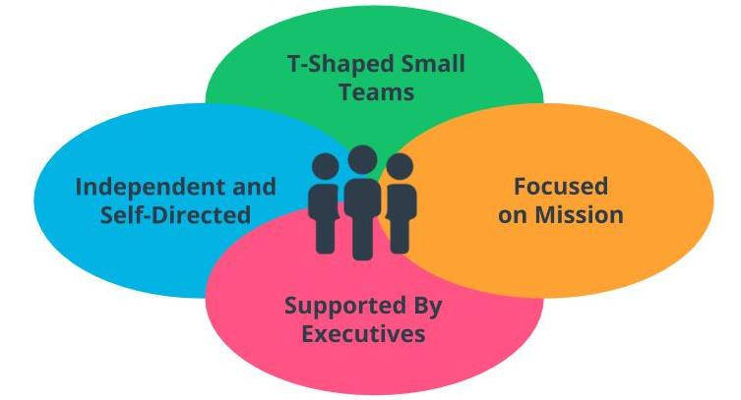

Attributes of High Performing Agile Teams

Building High Performing Agile Teams

Show TranscriptSummarize Video

Video Transcript

0:00

Now, let's look at how we can build a high performing Agile team,

0:04

that is committed to delivering value,

0:08

has the right attitude to improve and continually learn,

0:11

and which exhibits key elements of the agile mindset.

0:16

Senior leadership should inspire the Agile team.

0:20

This creates tremendous energy and enthusiasm in the team,

0:24

and this message from leadership,

0:26

makes the team feel inspired,

0:29

that the work they're doing is important to the organization.

0:32

A cross functional Agile team,

0:35

with different strengths and points of view,

0:38

brings about a richness to the solutioning options that the team comes up with,

0:42

due to the multiple perspectives.

0:44

Different cultural backgrounds and experiences

0:48

also creates an environment where the team benefits from different viewpoints.

0:53

An effective and creative team culture,

0:56

needs the team to have the breathing room to evolve,

0:59

in a guided and focused direction.

1:01

Some traditional managers insist on only putting the customer first

1:06

at the expense of the agile team's satisfaction.

1:10

An unsatisfied and claustrophobic team culture,

1:14

will deliver unsatisfactory results.

1:17

When Agile team members feel they can speak their mind freely,

1:22

it allows the team members to talk openly and constructively,

1:25

without getting defensive around challenging questions.

1:29

This drives better results,

1:31

since we're uncovering answers to difficult scenarios, more openly.

1:36

Clarity and communication from the executives,

1:39

is important for the Agile team,

1:41

to clearly know what direction they need to focus on.

1:44

A lot of this is filtered through the product owner.

1:48

Not being clear on what needs to be done,

1:51

or what the important deadlines are,

1:53

will result in the Agile team becoming increasingly frustrated.

1:58

Clear communication benefits everyone involved.

2:01

Group problem-solving approaches allows a team

2:05

with entirely different skill sets and perspectives to work together.

2:08

This stimulates creativity with unexpected breakthroughs via valuable solution options.

2:15

A smaller Agile team size,

2:18

allows for the team members to work together collaboratively,

2:21

towards identifying a viable solution.

2:24

The culture for meetings,

2:26

should not be one where,

2:28

team members feel like they're hostages

2:31

and must turn up even if there's no value in their attendance.

2:35

High-performing Agile teams, break away,

2:38

from the process-centric mindset

2:40

of scheduling meetings just for the sake of having them,

2:44

to follow a defined process.

2:46

Instead, Agile teams look to minimize unproductive meetings,

2:50

and instead utilize that time for value-driven work.

2:54

High-performing Agile teams work hard and produce fantastic results.

2:59

This requires a mechanism for recognition and rewards that shows appreciation.

3:04

Such appreciation techniques are built in

3:07

the various Agile frameworks that will be discussed in the next lesson.

3:11

Sometimes, simply just saying a simple "thank you"

3:14

for a job well done can be a significant motivator,

3:17

and source of encouragement.

3:19

The organization needs a structure where Agile teams are reminded periodically,

3:24

that they are valued on a consistent basis.

3:27

Uncommitted objectives, which are also known as stretch objectives,

3:32

are used to identify that work which is planned,

3:35

but the Agile team does not fully commit to completing it.

3:39

This allows for flexibility.

3:42

Uncommitted objectives create a drive in

3:45

high performing Agile teams to accomplish the impossible.

3:49

That desire to attain the extraordinary,

3:52

pushes the Agile team to try and conquer the stretch objectives as well.

3:57

This builds the team's confidence

3:59

and further fuels their desire to succeed.

4:03

Agile teams need to create authentically enjoyable conditions.

4:08

By encouraging the team members to be themselves and relish the experience,

4:12

having fun is a key ingredient in removing unnecessary toxicity,

4:17

that builds up in stale and unproductive teams.

4:21

In fact, having fun should be a key strategy,

4:25

for driven, and high-performing Agile teams.

4:29

These are the 10 steps to build a high performing agile team,

4:33

that is committed to delivering value,

4:36

improving, and having the right attitude to improve and continually learn.

4:41

In summary, a high-performing agile team never disappoints.

4:47

Such Agile teams, deliver phenomenal results consistently,

4:51

regardless of the challenges they encounter.

4:54

Such Agile teams, model desired behavior

4:58

and characteristics across the organization they reside in,

5:01

since they surpass both their leaders,

5:04

and customers' expectations without fail.

5:07

When organizations do it right,

5:10

Agile teams thrive to become high performing teams.

5:13

Senior leaders in an organization can turbocharge an Agile team,

5:18

by enabling them to be self-directed and independent.

5:22

This propels the Agile team forward,

5:24

by unleashing their ambition,

5:26

and cutting the unnecessary red tape,

5:29

that unnecessarily slows the flow of value.

Building a High Performing Agile Team

Let’s look at how we can build a high performing Agile Team:

* Inspire the Agile Team.
* Build a Cross-functional Diverse Team.
* Maintain Focus as Team Evolves.
* Encourage Innovation and Free Thinking.
* Communicate Clearly.
* Work Collaboratively to Solve Problems.
* Timebox Meetings.
* Recognize and Appreciate.
* Include Uncommitted Objectives.
* Take Time Out to Connect and Have Fun.

High Performing Agile Teams Never Disappoint

According to the American author Dan Pink, a high performing team is given purpose, an opportunity to develop mastery, as well as autonomy in decisions. Such a high-performing Agile Team never disappoints. Such Agile Teams deliver phenomenal results consistently, regardless of the challenges they encounter. Senior leaders in an organization can turbocharge an Agile Team by enabling them to be self-directed and independent.

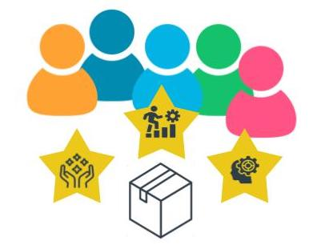

High Performing Agile Teams Never Disappoint

Remote Agile Teams

In an increasingly interconnected global business landscape, High Performing Agile Teams have to identify issues and benefits related to organizing and managing remote Agile Teams. The recent COVID-19 pandemic has genuinely changed the landscape with remote Agile Teams being accepted as a valuable norm.

Show TranscriptSummarize Video

Video Transcript

0:00

In an increasingly interconnected global business landscape,

0:04

high-performing agile teams have to identify issues and

0:08

benefits related to organizing and managing remote agile teams.

0:14

The recent COVID pandemic has genuinely changed the landscape,

0:18

with remote agile teams appearing to be quite an acceptable and valuable norm.

0:23

So let's look at how to implement remote working properly in agile teams.

0:28

First, limited communication can impact team bonding.

0:32

Remote teams need to be particularly careful with the pitfalls of limited communication,

0:36

which can impact team bonding quite directly.

0:39

Technology now offers numerous options to creatively connect as a team.

0:44

A virtual event where the Agile team gets together and does not discuss work,

0:50

helps break down built-up stress between team members.

0:53

It goes a long way in helping a team gel and bond.

0:57

Virtual game nights or even just a virtual coffee session works wonders.

1:03

Time zone differences can indeed be a challenge.

1:06

Since global remote teams find it hard to sync up calendars,

1:10

this requires some upfront planning to reach

1:13

some middle ground to ensure everyone as a team connects with some frequency.

1:18

The opportunity to work from home seems like a luxury,

1:21

but it adds lots of distractions to the team member's work life.

1:26

Moreover, for some team members,

1:29

the risk of working considerably more than the normal working hours in a regular work

1:33

setting can erode into one's personal life and health.

1:38

Having a clearly defined schedule for work as well as

1:42

home office location helps mitigate some of these challenges.

1:47

Fewer opportunities for simple catch-ups.

1:50

In an innovative and dynamic Agile team,

1:53

you might feel that replacing

1:54

face-to-face interactions reduces the collaborative moments.

1:58

However, Agile team members need to remember that virtual communication tools,

2:04

make our communication experience pretty close to face-to-face when done right.

2:10

Valuable simple catch-ups are still possible.

2:14

Lack of team cohesion.

2:16

Remote Agile teams, much like any team,

2:20

have the risk of losing cohesion.

2:22

However, with remote teams,

2:25

the risks are higher in that the geographical,

2:28

cultural, and language barriers may add to

2:31

the confusion around the vision, roles, and objectives.

2:35

The product owner and facilitator must work together

2:39

to ensure a clear product vision has been established.

2:42

there is clarity on the agile team's roles in terms of what is

2:45

included versus what is excluded within the team's responsibilities,

2:50

There needs to be more frequent reminders of

2:53

the value-driven objectives that the Agile team is working towards.

2:58

In summary, remote agile teams are definitely here to stay for the foreseeable future.

3:04

The COVID pandemic has resulted in a sea change in terms of

3:08

the acceptance and realization of the value of remote teams.

3:11

While those who are less prepared are paralyzed by

3:15

fear in the face of pandemic-related threats to the business world,

3:19

for a multitude of successful organizations,

3:22

the ability to continue to develop and maintain

3:26

strong remote teams is a high-priority opportunity.

Implementing Remote Agile Teams

Working with a remote Agile team successfully requires attention to the following:

* Team communication.
* Time Zone Differences.
* Work From Home Best Practices.
* Catch-Ups.
* Lack of Team Cohesion.

Remote Agile teams are definitely here to stay for the foreseeable future. The COVID-19 pandemic has resulted in a sea change in terms of the acceptance of the value of remote teams.

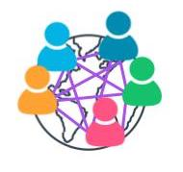

Remote Teams Are Here to Stay!

Additional Resources

* Andy Fieldhouse. ***Getting Teamwork Right: The Key to Happy, Successful and Resilient Teams***. Rethink Press, 2020.  
  This book discusses in detail how to create highly functional teams.
* Daniel H. Pink, ***Drive: The Surprising Truth About What Motivates Us***, Riverhead Books, 2011.  
  In this book, Dan Pink thoroughly covers what drives skilled teams to deliver value.

# Exercise: High Performing Agile Teams

LessonDownloads

### High Performing Agile Teams

High performing Agile Teams don't happen by accident. Team members need to be coached and nurtured to develop the skills and practices that make them more effective team members.

Review the [**SocialKare.gov Case Study(opens in a new tab)**](https://video.udacity-data.com/topher/2020/September/5f5f6bc7_agnd-c1-foundations-of-agile-socialkare.gov-case-study/agnd-c1-foundations-of-agile-socialkare.gov-case-study.pdf). How can we help the SocialKare.gov Team evolve into a high performing Agile team? Select three team members and identify specific coaching recommendations to move to a more high performing model.



1. Solution: High Performing Agile Teams

LessonDownloads

My Solution

Show TranscriptSummarize Video

Video Transcript

0:00

In this exercise, you are asked to identify

0:03

Agile team members who you can work with to build a high-performing Agile team.

0:09

Using the template provided,

0:11

you had to identify

0:12

three specific recommendations to move to a more high-performing model.

0:17

Let me share my responses.

0:19

John Details, as a facilitator, should

0:23

focus on facilitation and not technical solutioning.

0:27

John needs to let the socialcare.gov team be self-organized and self-directing.

0:33

John's former technical background and detail-oriented nature

0:37

might inhibit his ability to allow the team to be more autonomous.

0:42

He will need to be particularly careful to not stifle

0:45

the team's innovative and creative side to drive better business value.

0:51

Sarah Tenure, the product owner,

0:55

should listen to the Agile team for their input on priorities.

0:59

Let their voice be heard,

1:01

but ultimately make the final priority decisions.

1:04

Sarah should not interfere in the agile team's technical decisions at socialcare.gov.

1:09

Sarah is a tremendous asset with her business knowledge.

1:13

She will need to temper her desire to make

1:15

all decisions by being more collaborative with the team

1:19

giving the space needed to the facilitator to run

1:22

the ceremonies and work to resolve any impediments.

1:26

Tim Devs, an Agile team member,

1:30

should allow developers on the team to develop cross-functional skills,

1:35

as well as work to collaborate with the business more proactively.

1:39

Tim will have the challenge of not falling into the trap of micromanaging the

1:43

developers within the SocialKare.gov Agile team since they report to him.

1:48

He must give them the room to innovate and identify solutions.

1:52

Tim will also need to accommodate

1:55

the long-term goal of building a cross-functional team where

1:58

developers are given an opportunity to expand

2:01

their skills in an area outside their specific vertical.

2:05

Did you have different ideas for coaching the Agile team?

2:08

What were your ideas?

My Solution

* John Details, as a Facilitator, should Focus on facilitation and not technical solutions; John needs to let the SocialKare.gov team be self-organized and self-directed.
* Sarah Tenure, the Product Owner, should Listen to the Agile Team for their input on priorities. Sarah should not interfere in the Agile Team’s technical decisions at SocialKare.gov.
* Tims Devs, an Agile Team member, should allow developers on the team to develop cross-functional skills, as well as work to collaborate with the business more proactively.

# Organizing an Optimal Agile Team and Non-Core Roles

LessonDownloads

## What Are Size, Structure, and Cross-functional Skills in an Agile Team?

Show TranscriptSummarize Video

Video Transcript

0:00

An optimal Agile team sizes somewhere between

0:03

5 to 12 cross-functional and multi-skilled resources.

0:06

An Agile team of less than five would make it difficult to have

0:10

all the competencies needed to do all the work within this one team.

0:14

Since an Agile team should be a multidisciplinary unit tackling a common goal.

0:19

This is very different from a traditional waterfall structure, where

0:23

the different skills are broken out into separate teams,

0:27

which creates unhealthy and fragmented silos.

0:31

An Agile team larger than 12 skilled resources,

0:34

will make it difficult to self-direct and self-organize,

0:38

with increasing noise due to the number of team members.

0:42

As the number of team members increases,

0:44

the number of communication channels also increase.

0:48

In this diagram, N is the number of participants in the team.

0:53

As N increases, the communications channel formula of N times

1:00

N minus 1 divided by 2 shows that the number

1:03

of communication channels within the team increases dramatically.

1:07

This creates more noise and distractions within the Agile team.

1:11

The ideal maximum size recommended by agilists is 12 or less.

1:17

I've seen Agile teams larger than 12 quickly

1:20

get entangled in communication gaps and confusion.

1:23

Agile teams are no different than any other teams,

1:26

where role clarity is an important prerequisite.

1:29

In an Agile environment,

1:32

since things are evolving at a fast pace,

1:35

a lack of clarity around roles can cause considerably more stress,

1:39

confusion, and even unhealthy conflict.

1:42

Again, as agilists, we regularly have to

1:46

remind Agile organizations of the core roles and their responsibilities.

1:50

With the product owner being the voice of the customer and product champion.

1:55

The facilitator, as a servant leader,

1:59

ensures the team functions as smoothly as possible,

2:03

and the close-knit Agile team is responsible for

2:07

determining how to get the work done that the product owner has prioritized.

2:12

There's tremendous value in autonomous,

2:15

self-organizing and cross-functional Agile teams.

2:19

I regularly see them lead to greater success in delivering valuable

2:23

product features iteratively in complex organizational environments.

2:28

Cross-functional Agile teams exhibit T-shaped skills as discussed earlier.

2:34

Such teams ignite innovation,

2:38

break inefficient organizational silos,

2:41

and maintain a consistent flow of work in

2:44

value delivery in a more collaborative environment.

2:47

What is a cross-functional Agile team exactly?

2:51

A cross-functional Agile team consists of

2:54

team members in which each team member has different skills.

2:58

But they do not restrict themselves to just adding value in that one skill set.

3:04

Rather, in a cross-functional Agile team,

3:08

since everyone is working towards a common goal,

3:11

all team members are expected to exhibit T-shaped skills.

3:15

By stretching themselves beyond

3:17

just their specific expertise to help wherever the team needs assistance to move forward.

3:24

Cross-functional Agile teams are best run as small,

3:27

self-directed teams of 5 to 12 resources.

3:31

With a collaborative culture,

3:33

team members offer their own perspective,

3:36

which leads to more innovative solution options and

3:39

can become a significant competitive advantage.

### Optimal Agile Team has Between 5-12 Members

* An Agile Team size of less than 5 would make it difficult to have all the competencies needed to do all the work within this one team since an Agile Team should be a cross-functional and multi-disciplinary unit tackling a common goal.
* An Agile Team larger than 12 skilled resources will make it difficult to self-direct and self-organize. As the number of team members increases, the number of communication channels also increases.

### Clarity and Respect for Core Roles is Critical

Role clarity is an important prerequisite.

Agilists have to remind Agile organizations of the core roles and their responsibilities:

* Product Owner- Voice of the Customer(VOC) and Product Champion
* Facilitator- A Servant Leader
* Agile Team- Responsible for determining how to get the work done that the PO has prioritized

Cross-functional Agile teams are best run as small self-directed teams of 5-12 skilled resources.

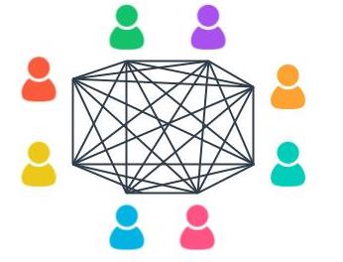

More Communication Channels = More Noise

## Non-Core Roles

While Non-Core Roles are not defined as mandatory in all Agile Frameworks, they can play a key role in the success of Agile Product Delivery.

* **Stakeholders** - Stakeholders can include Customers, Users, Sponsors, and others who have an interest in the product being worked on, but are not involved in the day-to-day development of the solution results.
* **Vendors and Strategic Suppliers** - Vendors and Strategic Partners provide products and services that are usually not within the core competencies of the organization or Agile Team.
* **Center of Excellence (CoE)** - Many organizations have a Center of Excellence focused on either Project or Product Delivery. A CoE often provides guidance on Governance and Reporting requirements to executives and regulators.
* **Enterprise Architect** - Reviews technical solutions to ensure they align with the overall organization's architecture.
* **Domain Subject Matter Expert** - Provides valuable support to the PO and Business Analyst on domain knowledge.

A successful Agile Team is typically both influenced and supported by several key Non-Core Roles.

### Coaching Models

#### Dreyfus Model of Skill Acquisition

The Dreyfus model presents a simple-to-understand framework for measuring an individual’s progress in any skill they are looking to acquire and gain expertise in. The five developmental stages identified in the Dreyfus Model for Skill Development are:

1. Novice
2. Advanced Beginner
3. Competent
4. Proficient
5. Expert

Read more about the Dreyfus Model of skill acquisition: [**The Five-Stage Model of Adult Skill Acquisition(opens in a new tab)**](http://www.bumc.bu.edu/facdev-medicine/files/2012/03/Dreyfus-skill-level.pdf)

#### Shu Ha Ri

Shu Ha Ri has its origins in Japanese Martial Arts. It is presented by experts as a way of thinking when learning a new skill. Alistair Cockburn is credited with introducing it in the Agile world when it comes to acquiring Agile skills for product development. There are three stages in Shu Ha Ri’s knowledge acquisition model:

* **Shu**: Here the Agile team member mimics and follows the teachings of an expert.
* **Ha**: At the Ha stage, team members start to experiment and begin to dig deeper into the theory that is driving the expert’s teachings
* **Ri**: When someone reaches the Ri stage, they have directly experimented and experienced how teaching is beneficial to the Agile team’s maturity. This allows them to get creative and adapt to their unique circumstances and organizational context.

You can read more about Shu Ha Ri here:

* [**Shu Ha Ri: An Agile Adoption Pattern(opens in a new tab)**](https://www.accenture.com/us-en/blogs/software-engineering-blog/shuhari-agile-adoption-pattern)
* [**Becoming agile with ShuHaRi(opens in a new tab)**](https://www.pmi.org/learning/library/becoming-agile-with-shuhari-9649)

### New Terms

* **Center of Excellence (COE)**: A unit comprised of seasoned experts in the organization that provide the Agile team support, best practices, guidance, and perhaps even training on Agile practices
* **Enterprise Architect (EA)**: A team member who ensures IT and the business units are aligned

# Exercise: Non-Core Roles On An Agile Team

LessonDownloads

### Identifying Non-Core Roles at SocialKare.gov

Agile Teams have non-core roles too! Review the [**SocialKare.gov Case Study(opens in a new tab)**](https://video.udacity-data.com/topher/2020/September/5f5f6bc7_agnd-c1-foundations-of-agile-socialkare.gov-case-study/agnd-c1-foundations-of-agile-socialkare.gov-case-study.pdf) and identify some of the non-core roles that make sense for the SocialKare.gov team. Explain why those roles are necessary for the SocialKare.gov team.



My Solution

Show TranscriptSummarize Video

Video Transcript

0:00

The exercise here entails building upon

0:02

the three core roles already identified in the previous exercise.

0:06

The ask was to recommend

0:08

three non-core roles and their value to the Agile team using the template provided.

0:14

Here's how I would complete this exercise.

0:17

Senior sponsorship is critical to the success of any product delivery.

0:21

Jane Dallas will fit into this role.

0:24

A sponsor provides the formal authorization and

0:27

funding to proceed with building a product or solution.

0:30

An enterprise architect will be

0:33

a valuable resource for the technical team members to seek guidance on

0:37

to ensure whatever they develop is in alignment with

0:41

SocialKare.gov's enterprise-wide architectural model.

0:45

The Domain Subject Matter Expert can be very beneficial

0:48

for the Product Owner as well as Business Analyst.

0:52

This person can be called upon as needed to provide domain knowledge and advice.

0:57

What non-core roles did you come up with?

Recommend Three Non-Core Roles

* **Sponsor** - Senior sponsorship is critical to the success of any Agile product delivery.
* **Enterprise Architect** - An Enterprise Architect will be a valuable resource for the technical team members to seek guidance on to ensure whatever they develop is in alignment with SocialKare.gov's enterprise-wide architecture model.
* **Domain Subject Matter Expertise** - This individual can be very beneficial for the Product Owner, as well as Business Analyst. This person can be called upon as needed to provide Domain knowledge and advice.

# Agile Governance

LessonDownloads

## What Is Agile Governance?

Show TranscriptSummarize Video

Video Transcript

0:00

Let's look at Agile Governance.

0:02

Effective Agile governance is essentially about making decisions.

0:06

Now, in order to enable effective Agile governance,

0:11

leadership will need to be comfortable with decentralizing

0:14

tactical decisions that the Agile team needs

0:18

to make frequently or within a tight timeframe.

0:21

This allows the Agile team to self-manage but within agreed tolerances.

0:28

Setting these tolerances or boundaries is essential for Agile governance.

0:33

This is particularly true for time and cost.

0:36

When tolerances are in danger of being exceeded,

0:39

agile product delivery frameworks recommend de-scoping the lower priority items.

0:45

Timeboxing is paramount in Agile,

0:48

within which a valuable product must be provided to the client base.

0:53

Yet, Agile product delivery and the associated governance model

0:58

must accept that de-scoping may occur to respect the timebox.

1:04

In Agile governance, decentralized decision-making empowers the Agile team,

1:10

to openly communicate and engage in

1:13

constructive debate to quickly resolve issues and challenges.

1:18

One of the cruxes of decision-making in Agile teams,

1:22

is that at the end of the ceremony or meeting,

1:25

all team members collectively and unanimously

1:30

commit to the decisions being made, regardless of where their vote had been.

1:35

This mindset is extremely advantageous and

1:39

aligns the entire team towards shared outcomes.

1:43

When done right, Agile governance delivers on goodwill and trust,

1:48

a clear understanding of roles,

1:50

as well as the acceptable thresholds and tolerance levels for decentralized decisions.

1:56

Agile governance, being under the umbrella of the Agile manifesto,

2:00

promotes a light and simple governance structure.

2:04

It is the Agile team themselves who typically decide on

2:08

the metrics they must leverage to self-monitor their team's progress.

2:13

Such metrics are easy to measure, based on actual performance, and transparent to all.

2:19

This allows the Agile team to use these metrics to improve continually.

2:23

Let's be clear that the usual principles of assurance will not be compromised.

2:30

However, the assessment relies more on observation and engagement,

2:35

rather than cumbersome reports and delayed lengthy presentations.

2:39

Transparent and open communication

2:42

and engagement is pivotal to assure Agile product delivery.

2:46

Now, while decentralized decision-making is encouraged,

2:51

certain decisions will continue to remain centralized in an Agile environment.

2:55

These centralized decisions tend to be strategic decisions that span

3:00

a longer timeframe and have a larger organization-wide impact.

3:05

In addition, centralized decisions make

3:08

sense that an organization's leadership needs to make

3:12

for rare decisions that require more detailed and deeper analysis.

3:18

Again, effective Agile governance is essentially about making decisions in

3:24

a simpler and lighter manner, per the agile manifesto's guidance to keep things simple.

### Effective Agile Governance is about Making Decisions

In order to enable effective Agile governance, the following needs to be kept in mind:

* Tolerances Are Essential For Agile Governance.
* Decentralized Decision Making Empowers The Team.
* Agile Governance Delivers Goodwill and Trust.
* Agile Promotes Light and Simple Governance.
* Strategic and Long-Term Decisions Remain Centralized.

Effective Agile governance ensures decisions are made in a simpler and lighter manner per the Agile Manifesto’s guidance to keep things simple.

### Additional Resources

* [**Governing Agile Teams(opens in a new tab)**](https://www.pmi.org/disciplined-agile/people/governing-agile-teams) - This article discusses various facets of what is and what is not considered Agile governance.
* [**Organizing: Centralization and Decentralization(opens in a new tab)**](https://www.toppr.com/guides/business-management-and-entrepreneurship/organizing/centralization-and-decentralization/) - This article compares the advantages of centralized and decentralized organization and describes the factors for determining the degree of decentralization decision-making.

# What Kills High Performing Teams

LessonDownloads

## Pitfalls That High Performing Teams Should Avoid

Show TranscriptSummarize Video

Video Transcript

0:00

While it is wonderful for me to see

0:02

a high-performing Agile team in place at a client site,

0:05

nothing is more frustrating than to see the same Agile team fall apart and die.

0:10

I'm going to share some of the more common reasons

0:13

that high-performing Agile teams disintegrate,

0:16

as well as to how to avoid such a dismal scenario.

0:20

Pitfall number one: conflicts are not managed effectively.

0:25

Agile teams tend to exist in environments where

0:27

expectations are high from key stakeholders.

0:30

I have unfortunately seen that many times due to pressure,

0:35

rather than continuing to avail of constructive conflicts as a course of collaboration,

0:40

high-performing Agile teams spiral into an adversarial approach.

0:46

It is important to regularly remind the Agile team

0:50

of the value of respectfully discussing differing opinions and suggestions.

0:55

After all, the goal is to have win-win scenarios where

0:59

both the Agile team and the business are winners together.

1:03

Pitfall number two: the blame game begins.

1:08

Again, Agile teams are expected to deliver consistently.

1:12

However, there needs to be a tolerance for some failures

1:16

since Agile teams work in fast-paced situations.

1:20

The blame game and negative criticism quickly escalates to unhealthy conflict.

1:26

This can quickly lead Agile teams down the unhealthy path of getting defensive,

1:31

which leads to disengagement.

1:33

The entire fabric of collaboration can fall apart as a result.

1:38

The smarter and healthier outlook is to

1:41

continue to keep the Agile team on a learning mindset.

1:45

This encourages a level of curiosity and solution-oriented thinking.

1:50

Pitfall number three: rules of engagement are not followed.

1:55

In a mad rush to deliver Agile teams sometimes forget

1:59

the basics of needing to honor the mutually agreed-upon rules of engagement.

2:05

Open and honest communication requires adherence to team rules of engagement.

2:10

The facilitator must ensure the Agile team

2:14

honors the agreed-upon rules of engagement and that

2:17

team communications are frequent and relevant to avoid

2:20

a high-performing Agile team from commencing its decline.

2:25

Otherwise, it kills trust.

2:27

When there are fractures in trust,

2:30

there is no genuine Agile team.

2:33

It is important for the Agile team to slow down when necessary,

2:37

to regroup and make sure everyone is collectively heading in the same direction.

2:42

Pitfall number four: the spark or passion is dimmed.

2:47

High-performing Agile teams are

2:50

fueled by the perception of the value of the work they are delivering.

2:54

If the Agile team starts to perceive that their work is

2:58

not as valuable or not as important to the organization's leaders,

3:02

it can annihilate motivation.

3:05

High-performing agile teams also need to continually be aligned with leadership's vision.

3:11

When this starts to get foggy,

3:14

the product owner needs to quickly step in to clarify.

3:18

If Agile teams are able to maintain their sense of

3:22

psychological safety and avoid the pitfalls I mentioned,

3:26

they will continue to experience high levels of engagement,

3:30

enthusiastic motivation, and incrementally better team performance.

### What Kills High-Performance Teams?

* **Pitfall #1**: Conflicts are not managed effectively; it is important to regularly remind the Agile Team of the value of respectfully discussing differing opinions and suggestions.
* **Pitfall #2**: Blame game begins; there needs to be a tolerance for some failures since Agile Teams work in fast-paced situations. Such blame games and negative criticism quickly escalate to unhealthy conflict. The smarter and healthier outlook is to continue to keep the Agile Team on a learning mindset.
* **Pitfall#3**: Rules of Engagement are not followed; the Facilitator must ensure the Agile Team honors the agreed-upon rules of engagement and that team communications are frequent and relevant to avoid a high performing Agile Team from commencing its decline.
* **Pitfall #4**: Spark or passion is dimmed; if the Agile Team starts to perceive that their work is not as valuable, it can annihilate motivation. When the product vision starts to get foggy, the Product Owner needs to quickly step in to clarify.

### Quiz Question

What kills the momentum of a high performing Agile team?



Any conflict



Discussing opportunities for improvement



Following rules of engagement



When the Agile team does not have a view of the product vision

Submit

### New Terms

* **Blame Game**: Circumstances in an Agile team where team members try to blame each other for issues and challenges rather than working together to collaboratively resolve what they are encountering

### Additional Resources

* [**Governing Agile Teams(opens in a new tab)**](https://softwaremind.com/8-agile-mistakes-that-are-killing-your-development-projects-and-how-to-avoid-them/): This blog post covers various abysmal Agile implementation mistakes.

# Lesson Recap

### Lesson Recap

In this lesson, we talked about:

* The characteristics of high performing Agile Teams.
* We then proceeded to talk about the size, structure, and skills of a High Performing Team. We discussed how Agile frameworks recommend a team size of between 5-12 skilled resources that are self-organizing and cross-functional with T-shaped skills.
* We then looked at Agile governance and how, based on the Agile Manifesto’s guidelines, Agile recommends a lightweight and simple approach to governance. Where possible, decentralized decision-making is encouraged.
* We finished up by talking about some pitfalls in which High Performing Agile Teams disintegrate and how to avoid those situations.

This lesson emphasizes how High Performing Agile Teams help organizations survive in such turbulent times. As the pace of change increases and the world of work makes ever greater demands on teams, high performing Agile Teams will become increasingly important.

In the next lesson, we will look at Agile Frameworks.

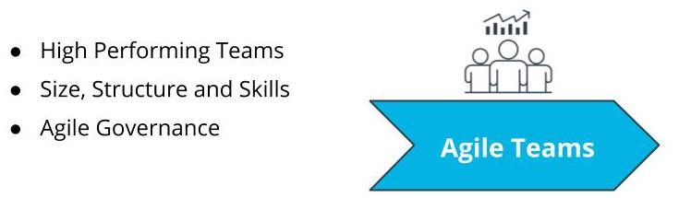

What We Covered In This Lesson

# Glossary

LessonDownloads

## New Terms In This Lesson

| **KeyTerm** | **Definition** |
| --- | --- |
| Adjourning | In the Tuckman Model's Adjourning stage, the Agile team’s goals have been completed, and the focus is on wrapping things up before team members get reassigned to other work |
| Blame Game | Circumstances in an Agile team where team members try to blame each other for issues and challenges rather than working together to collaboratively resolve what they are encountering |
| Center of Excellence (COE) | The part of the organization that provides the Agile team support, best practices, guidance, and perhaps even training on Agile practices |
| Enterprise Architect (EA) | A team member who ensures IT and the business units are aligned |
| Facilitator | The person who ensures that the Agile Team moves along at an acceptable pace towards the business objective and removes any blockages or impediments that may be slowing the team |
| Forming | Uncertainty is high during the Forming Stage in the Tuckman Model; this is when the team is getting accustomed to each other, ground rules are being established, and everyone is informed of the goals and objectives |
| Innovation Hub | Proactively working towards continual improvement with no compromise on technical excellence and quality |
| Norming | In the Tuckman Model's Norming stage, a sense of trust develops among team members; interpersonal differences are taken care of now, and a sense of collaboration for the team's collective benefit arises |
| Performing | In the Tuckman Model's Performing stage, the team has matured into a well-established unit with a sharp focus on collaborative value delivery |
| Self-Directed | Team members are empowered to decide among themselves who does what and how it is to be accomplished in a collaborative manner |
| Self-Organized | The team determines tasks and makes technical decisions about the work to be done after being given priorities by the PO |
| Storming | In the Tuckman Model's Storming stage, the team goes through a level of chaos in which there is confusion around the goals and objectives of the project, as well as confusion around roles and responsibilities |
| T-Shaped Skills | A strong vertical skill combined with the capability and willingness to step into other cross-functional needs |
| Team Member | The people who accomplish the actual work of completing and delivering a potentially shippable version of the product at the end of each iteration |